Invitation to Quote | 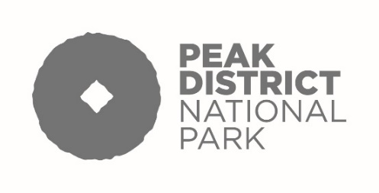

- The Peak District National Park Authority invites the submission of Quotes for the provision of consultancy services in relation to supporting a prosperous rural economy.

- The consultancy service to be provided is set out in the ‘Specification of Requirement’ dated 18 February 2025.

- The value is estimated to be less than £30,000 (inclusive of VAT).

- Responses should be submitted by 5.00pm on 21 March 2025 by email to Tenders@peakdistrict.gov.uk .

The following, and only the following, must be used in the subject line: “REF: LOCAL PLAN REVIEW: supporting a prosperous rural economy Quote”.

All attachments must be in pdf form.

- The Quotation should include:

5.1 Fully completed, signed and dated Form of Quote in Appendix 1.
5.2 Completed, signed and dated Non Collusive Tendering Certificate in Appendix 2.

- The evaluation criteria are set out in Section 15 of the Specification of Requirement.

