
A Special Place: Mountain Environment Pre-visit Activities – Science (Forces)

Teachers’ Notes

Background information:

During your visit to the Peak District for your ‘Mountain Environment’ day, the children can climb a variety of hills. Although not officially ‘mountains’, they will give children a taste of how it feels to be at altitude and the understanding that the ground they walk on was formed millions of years ago.

Thorpe Cloud (near Dovedale) reaches a height of 287m (942ft) and is an excellent example of a limestone reef knoll (a large mound of limestone material that built up on the sea floor) around 350 million years ago. Limestone itself is formed from calcium from the bodies of sea animals such as coral and molluscs. The name Thorpe is thought to have a Viking origin.

Shutlingsloe (near Macclesfield Forest) was formed by gritstone laid down in the Carboniferous period and reaches a height of 506m (1, 660ft). Its name is thought to derive from ‘Scyttel’s Law’ (‘Scyttel’s Hill’).

Mam Tor reaches 517m (almost 1,700ft) and was formed from shale. Its name is thought to originate from ‘Mother’s Hill’ due to the small hills formed at its base due to landslips.

There are 5 basic types of mountain.
- Fold mountains
- Fault-block mountains
- Dome mountains
- Volcanic mountains
- Plateau mountains

The activities only concentrate on the first three types.

Fold mountains are the most common type and are formed when the Earth’s tectonic plates push together making the crust ‘buckle’ and fold. This can be shown by pushing a rectangle of cloth from both sides into the centre so that the centre rises to form the ‘mountain’.

Fault-block mountains are when faults (cracks) appear in the Earth’s surface so that some blocks rise upwards while others move downwards.

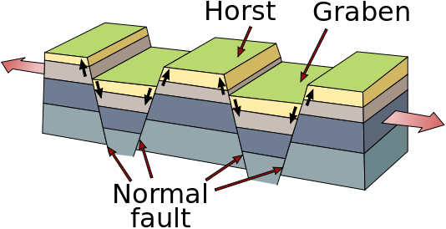

This can be demonstrated by cutting blocks of polystyrene (or flapjack!) so that they fit together until moved.

Dome mountains are formed when magma (molten rock) pushes the crust up without erupting on to the surface. The magma then cools and hardens. This can be demonstrated by inflating a balloon underneath a rectangle of fabric.

NB: Some children may have some knowledge of plate tectonics. You may decide that they need this information to be able to complete the tasks. However, it may be more beneficial for their critical thinking for them to arrive at their own conclusions.

Useful links* for teachers

http://www.primaryhomeworkhelp.co.uk/mountains/types.htm

http://www.bbc.co.uk/science/earth/surface_and_interior/mountain_formation

*The Peak District National Park is not responsible for the content of external sites

