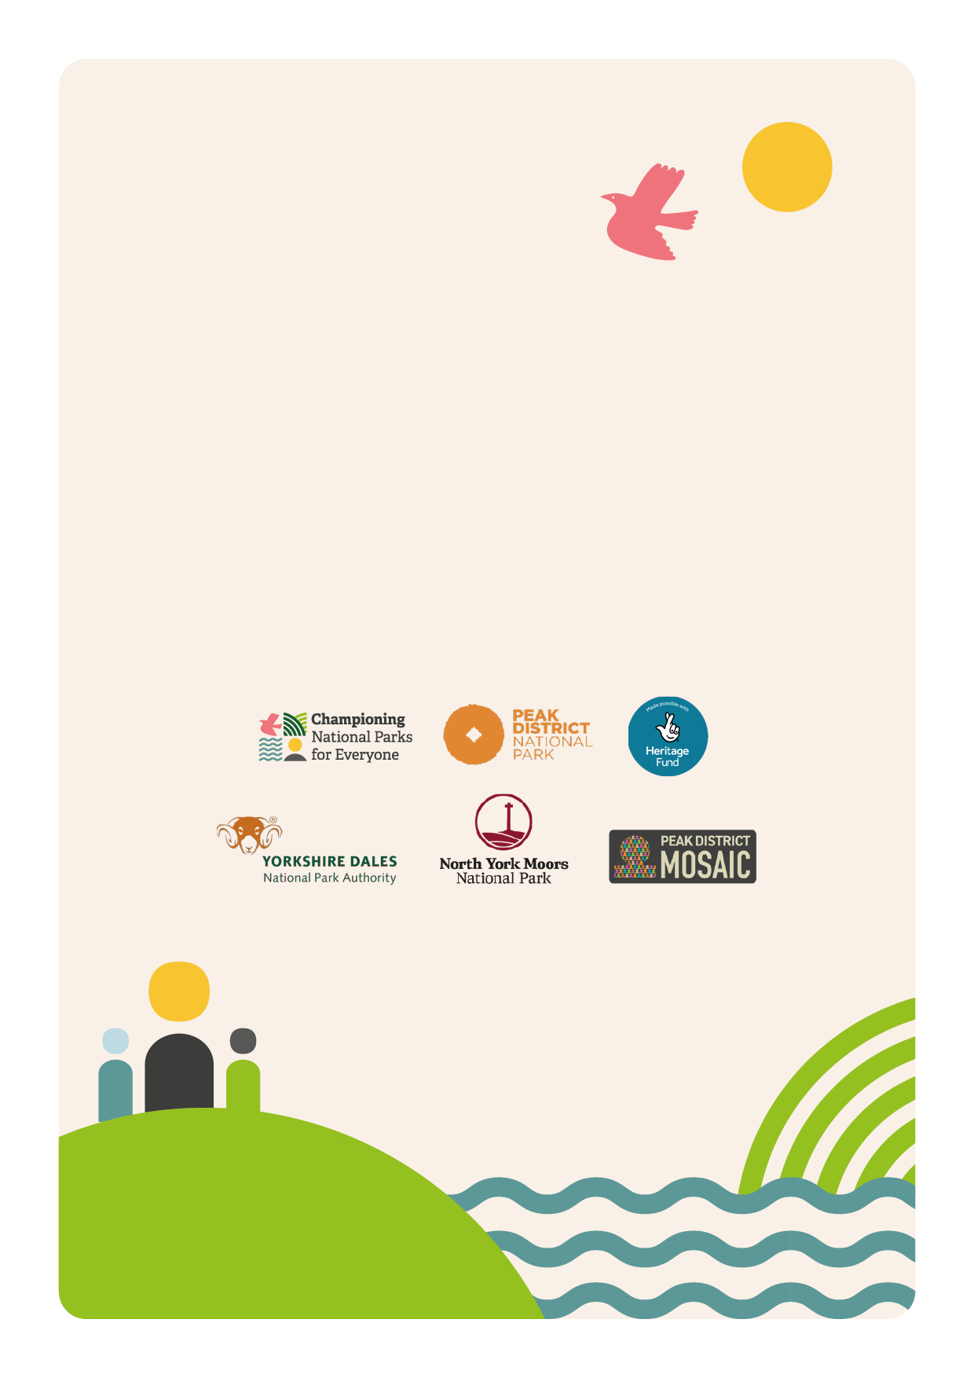
Community ChampionTraining: Peak District National Park

Application Form

Community Champion Training: Application Form
The Community Champion Training Programme is the heart of the Championing National Parks for Everyone project. Each National Park is delivering the Community Champion Training programme three times. There is capacity for twelve adults per cohort of training. This training is for adults from culturally diverse communities, who would like to develop their confidence and leadership so that they can share National Parks with their communities.
As numbers are limited, we have a short application form for you to fill out:

Basic Information
Full Name

Date of Birth

Email Address

Telephone Number

Medical Information
Any medical information we should be made aware of?

Any disabilities or specific considerations?

Next of Kin Full Name

Next of Kin Telephone

We would like to understand a little more about you. Please answer the following questions in 100 words or less;

- What sparks your interest with this training?

- How do you intend to use this training?

- We have a small bursary for participants of training to support with travel, equipment and childcare. Would you require a bursary? Please give details.

- How did you hear about this training opportunity?

Timeline:
- Sunday 18th May 2025: Closing date for Cohort 2 applications
- By Monday 19th May 2025: Applicants notified if they have a place on Training
- Day 1: Saturday 7th June 2025 from 10:00 – 16:00 at Brunt’s Barn (Grindleford)
- Day 2: Saturday 28th June 2025 from 10:00 – 16:00 at the Moorland Discovery Centre (Longshaw Estate)
- Days 3 + 4 (overnight residential): Saturday 19th and Sunday 20th July 2025 at Castleton Youth Hostel
- Day 5: Saturday 2nd August 2025 – from 10:00 – 16:00 at Longdendale Environmental Centre (Hadfield)
- Day 6: Saturday 25th October 2025 – 10:00 – 16:00 – location tbc
Thank you. Please send completed form to Andrea Antoniou (Project Officer CNPfE in Peak District National Park) via email andrea.antoniou@peakdistrict.gov.uk by 18th May 2025.

