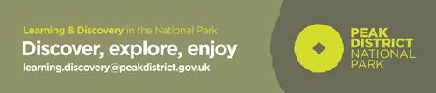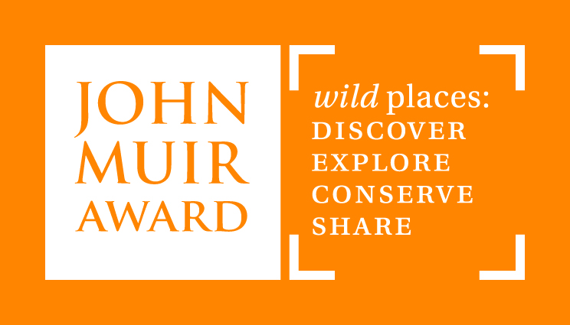
A Special Place: Mountain Environment Pre-visit Activities – Critical Thinking: Rucksack Debate

These activities can be carried out with the whole-class or as a ‘carousel’ of activities during a ‘mountain workshop’.

Objectives: To get the children to think about which clothing and equipment is needed in the mountain environment.

Resources: Rucksack(s), sets of mountain equipment/clothing cards.

Background information and instructions can be found in the teachers’ notes. These can be found on our ‘Peak Curriculum Resources’ page.

- Allow the children to discuss what type of things a mountaineer/walker might have in the rucksack.
- Get them to choose a card each from the rucksack without showing them to the rest of the group. They then describe the item and say why it is important on a mountain without naming it to see if the group can guess what it is.
- If a child doesn’t know what the object is or its use, they can place it to one side and choose another card.
- Get the children to discuss any items which are not familiar to them and why they may be useful on a mountain. They may want to discuss how the equipment works in detail e.g. what is the function of each part of the ice-axe? They may also want to think about what materials the items are made out of and why e.g. insulating materials for gloves and flask.
- Depending on the size of the group, get each child to choose one or more items. Explain to them that the mountaineer’s rucksack is too heavy and he/she can only keep 10 items in it. The children need to justify why their item(s) needs to be kept in the rucksack and think of reasons why the other items could be less important. They may want to make notes before starting the debate.

