

# Accessibility Guide for Castleton Visitor Centre

[castleton@peakdistrict.gov.uk](mailto:castleton@peakdistrict.gov.uk), [01629 816572,](tel:01629%20816572) <https://www.peakdistrict.gov.uk/visiting/visitor-centres/castleton>

**Contact for accessibility enquiries: Castleton Visitor Centre**

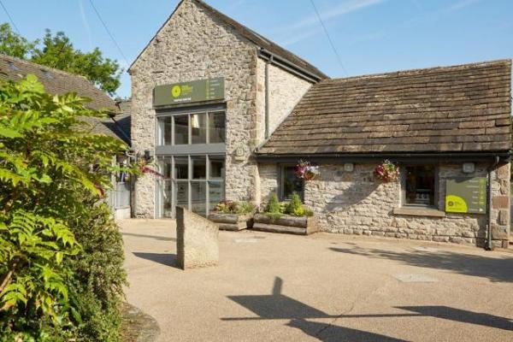

### Welcome

Castleton Visitor Centre is located adjacent to the main village car park surrounded by hillsides and overlooked by Mam Tor (the shivering mountain) and the ancient Peveril Castle.

The visitor centre is accessible for visitors with limited mobility, including wheelchair users. There are exciting interpretation displays, a dedicated space for Castleton Historical Society’s museum, an audio-visual room, retail area, a café and washroom facilities on site.

Please contact us if you require any further information about specific access needs or advice on planning your visit. Our experienced team are here to help you make the most of your visit to this spectacular area.

## At a Glance

### Level Access

* There is level access from the main entrance to:
  + Dining Table
  + Visitor Centre Desk
  + Accessible Toilet in The Blueberry Café
  + External Accessible Toilet at the Visitor Centre
  + Visitor Centre Shop
  + The Castleton Historical Society Museum
  + Castleton Village Playground
* There is level access from the car park to:
  + Castleton Visitor Centre outside seating

### Hearing

* The fire alarm has flashing lights.
* We have a hearing loop in At the visitor centre till/ information desk..
* Some staff have disability awareness training.

### Visual

* Glass doors and full-height windows have contrast markings.
* The walls and the doors have high colour contrast.
* Some parts of the venue have low lighting.
* The menu is in large print.
* We have information in large print.

### General

* There is at least 1 public toilet for disabled visitors.
* Some staff have disability awareness training.

## Getting here

Castleton Visitor Centre  
Buxton Road  
Castleton  
S338WN

#### Travel by public transport

* You can get to Castleton Visitor Centre by bus and train.
* There is a bus station in the centre of the village (0.2 miles / 0.3 km from the visitor centre) offering a regular service to and from Sheffield. Other destinations along the bus route includes other major villages and towns within the Peak District. From January 2023 - March 31st 2023, a new discounted route cost has been applied to many routes including those from Sheffield to many Peak District Villages; including Castleton. This link provides more details: www.gov.uk/guidance/2-bus-fare-cap. Bus times can be found on this link: www.derbysbus.info Please contact the bus company (principal operator) on the route you are interested in, to find out their bus accessibility. The bus stop is 0.2 miles / 0.3 km from Castleton Visitor Centre.
* The nearest train station is Hope Train Station. The train station is 2.2 miles / 3.5 km from Castleton Visitor Centre.
* Hope Train station is 2.2 miles from Castleton Visitor Centre. There are regular trains from Manchester and Sheffield.From this train station you can take a bus or taxi into Castleton and there is level access from the station to the car park and the road.Please note there is currently only wheelchair access on the platform arriving from Sheffield into Hope.  
  At Hope train station there is a Cab4U taxi booking service, with Northern Rail, but they need 2 hours notice for anyone requiring this service 08002 006060.  
  There are two level access train stations in the Hope Valley: Bamford (4.4 miles) and Hathersage (6 miles). Wheelchair accessible buses can be taken from both these stations into Castleton. Bus times can be found using this link: www.derbysbus.info

#### Travel by taxi

* You can get a taxi with Penny's Car's by calling 079177710771. The taxi company has a wheelchair accessible vehicle.
* You can get a taxi with TM Private Hire by calling 01298 812148. The taxi company has a wheelchair accessible vehicle.
* There are two fuel stations close to Castleton village.   
  Ascona, Sicklehome Petrol Station is located on Hathersage Road, Hope Valley S33 0EB. 01433 651173  
  There is level access into this building, with a level access toilet avaliable, but they corridoor measures 630mm leading to it, which is not wheelchair accessible. You can call for assistance before 8pm at night.   
  Hope Garage, Castleton Road, Hope, S33 6RZ. 01433 620333  
  This wonderful 'old fashioned service' is perfect for those who want to stay in the car, as this station provides attendant service only. If anyone requires assistance with car maintenance, the mechanics are extremely helpful.  
  There are public toilets including an accessible toilet, situated across the road.

#### Parking

* We have a car park. There are accessible parking spaces. The parking is less than 50 metres from the main entrance. Parking is not free.
* There is a drop-off point at the main entrance. The drop-off point has a dropped kerb.
* From the car park to the entrance, there is level access. The route is 1410mm wide, or more.
* There are 8 accessible parking bays in the visitor centre car park. Blue badge holders can park free of charge, provided they are parked within a marked bay and a valid blue badge is displayed clearly. The Visitor Centre car park is owned by High Peak Borough Council, so for any further information, please contact them directly.  
  Other car parking facilities in the village:  
  - Peak Cavern Car Park  
  There are no designated, marked accessible parking bays (the whole car park is unmarked).  
  For more information on parking costs and logistics, please visit www.peakcavern.co.uk.  
  There are designated customer car parks for Blue John Cavern, Speedwell Cavern and Treakcliffe Cavern (please note none of these caverns are wheelchair accessible). Please enquire directly for further information.   
  - Roadside parking; Old Mam Tor Road, Castle Street, Back Street, How Lane.  
  - There are private car parks for the following businesses, for use by patrons only (for further information, please contact them directly):   
  Ye Olde Cheshire Cheese Inn, The Peak Hotel, The George, Bulls Head and The Castle.

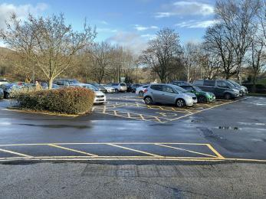  
Visitor centre accessible car parking spaces with yellow hatching

## Arrival

#### Path to main entrance

* From the street to the main entrance, there is level access.
* The path is 1410mm wide, or more.

#### Main entrance

* The main entrance has level access.
* The door is 1290mm wide.
* The main door is sliding and automatic.
* The Visitor Centre opening times are as follows:  
  Until 30 April 2023 - Every day: 10am to 4.30pm  
  From 1 May 2023 - Every day: 9.30am to 5pm

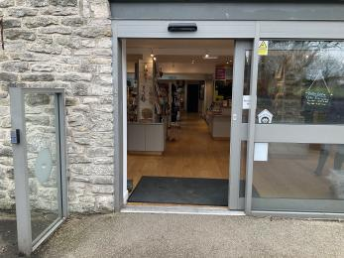  
Visitor Centre entrance with automatic doors and black entrance mat on wooden flooring

## Getting around inside

#### Visual Impairment - General Information

* We have contrast markings on all glass doors, contrast markings on all full-height windows and high colour contrast between walls and doorframes.
* Some parts of the venue have low lighting.

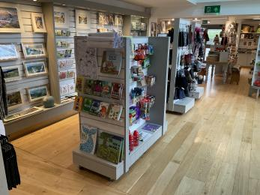  
Image showing good visual contrast between wooden flooring and white shop shelving

#### Ticket/ information desk

#### Visitor Centre Desk

* From the main entrance to the desk, there is level access. The door is 1290mm wide, or more.
* The desk has a low section.
* The lowered counter measures 720mm high.  
  Information can be provided in large print on request.  
  Staff assistance is avaliable.  
  There is a hearing loop at the till point/ information desk.

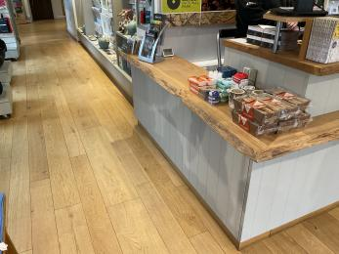  
Lowered counter in the visitor centre shop

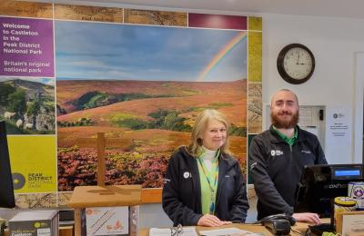  
Two staff members behind the information desk smiling

#### Public toilet

#### Accessible Toilet in The Blueberry Café

* There is a public toilet for disabled visitors.
* From the main entrance to the public toilet, there is level access. The toilet door is 910mm wide.
* The direction of transfer onto the toilet is to the left.
* There is 2000mm at the side of the toilet. There is 1300mm in front of the toilet. The toilet seat is 480mm high. The toilets have handrails.
* Height of the changing bench: 771mm

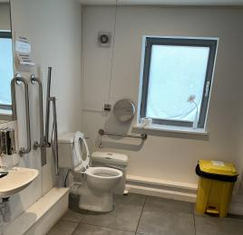  
Accessible white toilet with white sink and silver grab rails and large floor space.

#### Public toilet

#### External Accessible Toilet at the Visitor Centre

* There is a public toilet for disabled visitors.
* From the main entrance to the public toilet, there is level access. The direction of transfer onto the toilet is to the right.
* The toilet seat is 480mm high. The toilets have handrails.
* This public toilets in the visitor centre car park is locked daily at 17:00.  
  There are also some public toilets located next to the Castleton Coach Station, opposite The Peaks Inn. There are two accessible toilets.

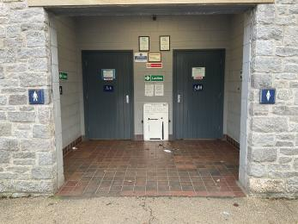  
The blue doors of the external visitor centre accessible toilets, surrounded by bricked walls

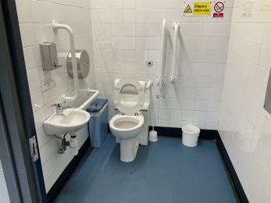  
Inside the external visitor centre toilets showing white features against a blue floor with black skirting

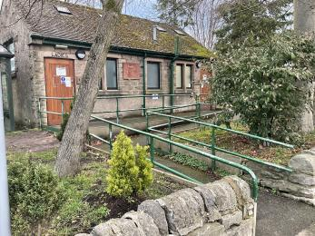  
External image of the accessible toilet block by the coach station

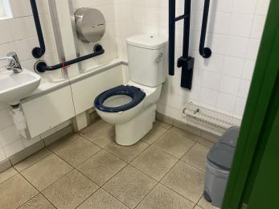  
Inside the accessible toilet at the coach station with blue and white contrasting toilet and grab rails

#### Shop

#### Visitor Centre Shop

* From the main entrance to the shop, there is level access. The door is 1290mm wide.
* The route through the shop is 800mm wide, or more.
* There is ample circulation space in the retail area of the visitor centre.  
  Assistance dogs are welcome and water bowls can be provided for them. Please ask staff for assistance.  
  The nearest spend area for assistance dogs is on a grassed area towards the back of the car park, to which there is level access.

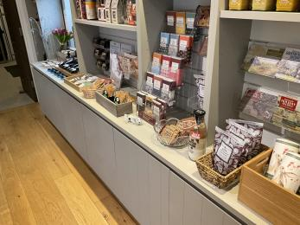  
Local products displayed on a shelf in the visitor centre shop

#### Place to eat and drink

#### Blueberry Cafe

* From the main entrance to the dining area, there is level access. The door is 1000mm wide.
* To get to a table, there are no steps.
* The menu is offered in large print.
* The dining area is self-service. If you need table service, staff can help you.
* The route through the dining area is 800mm wide, or more.
* There is background music.
* The table and plates have high colour contrast.
* We cater for sugar free (diabetic), vegetarian, gluten free (celiacs), lactose free (dairy free) and vegan specific diets.
* There is a quiet area of seating behind a curtain, which can be requested and seats up to 18 people.  
  There is a variety of seating with and without armrests, and there is also high stools.

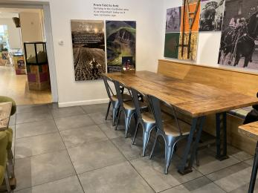  
Four metal and wooden chairs, large wooden table with historic images on the wall

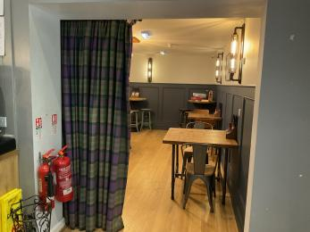  
Quiet, private dining area with tables and chairs behind curtain in the Blueberry cafe

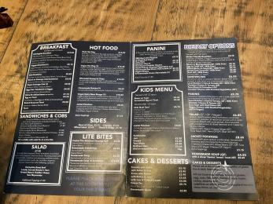  
Black menu with white writing showing a variety of food including dietary options in the Blueberry cafe

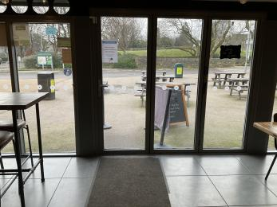  
Glass entrance doors to the Blueberry cafe showing a-frame sign outside

#### The Castleton Historical Society Museum

* From the main entrance to this area, there is level access. The door is 1290mm wide.
* This museum is accessed from the shop and main entrance of the visitor centre, as well as through the Blueberry Cafe.  
  The narrowest part of the musuem, between displays is 960mm.  
  There is an interactive gesture wall with visual and audio display.  
  There is a film about the National Park, which plays on a loop throughout the day and has audio and subtitles.  
  Information in display cabinets varies in heights and visual contrast.

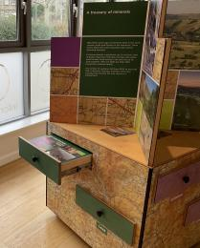  
Interactive display in the museum

## Getting around outside

#### Picnic Area

#### Castleton Visitor Centre outside seating

* From the car park to the picnic area, there is level access. Some tables have space for wheelchair users. You can bring your own food to the picnic area.
* There are a variety of picnic benches outside the visitor centre, including some wheelchair accessible benches.

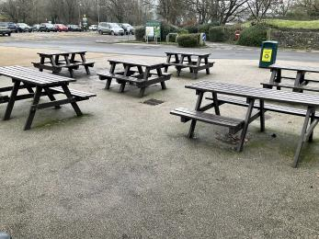  
Standard and wheelchair accessible picnic benches on the concrete outside the visitor centre

#### Castleton Village Playground

* From the main entrance to this area, there is level access.
* This village playground is situated in a quiet area, away from the main village, near the Hollowford Centre. From the centre of the village, take the lane: Millbridge, which leads into Hollowford Road. There are two metal gates leading into a grassed car parking area, just before the road forks with Robinlands Lane. This parking is for the village rugby field and the playground. This is a quite area, where people can escape the busy village environment, which is surrounded by stunning landscape views.

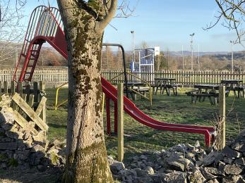  
Field and tree with red slide and picnic benches with blue sky in the background

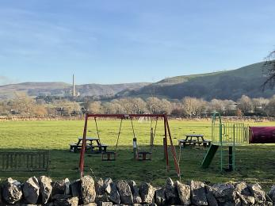  
Play equipment in a field with swings and view over the Peak District

## Customer care support

#### Accessibility equipment

* We provide wheelchairs. Wheelchairs are free.
* We have a hearing loop in At the visitor centre till/ information desk..
* Trampers (mobility scooters) will soon be avaliable to hire from the visitor centre. Please enquire within, or by calling 01629 816572.
* This is at the back of the car park on a grassed area. This area is level access.
* Enquire with the visitor centre about whether they are able to charge a mobility scooter.

#### Emergency evacuation procedures

* We have emergency evacuation procedures for disabled visitors.
* The fire alarm has flashing lights.
* In the case of evacuation, all customers inside the visitor centre and Blueberry cafe will be led to safety by a member of the team or by a member of the fire brigade.

#### Customer care support

* Some staff have disability awareness training.
* We have information in large print.

Guide last updated: 2 May 2023