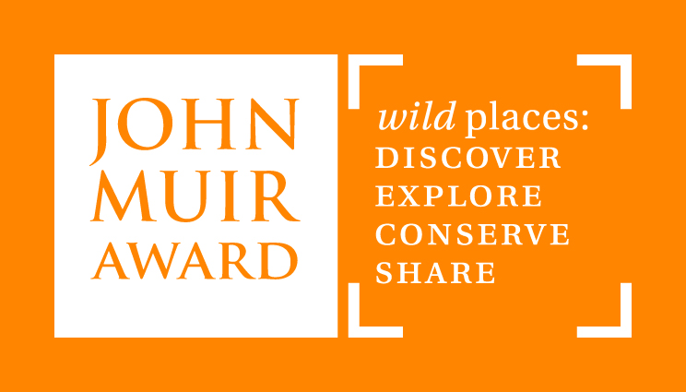
A Special Place: Mountain Environment Post-visit Activity – ‘Renewing the River’ Debate

This activity should be carried out after the children have a good understanding of the ways people, plants and animals interact with rivers and have visited one of our centres for a ‘River Study’ day.

Objectives: To get the children to think critically about the issues surrounding the management and use of rivers.

Resources: ‘Renewing the River’ presentation, cards for role-play. These can be found on our ‘Peak Curriculum Resources’ pag. You may want to record the debate using digital technology/and or use post-it notes for children’s thoughts. Optional instructions are in italics.

Activity:
- Recap what the children have found out about rivers through their pre-visit activities and whether their knowledge of/views about rivers have changed following their ‘River Study’ visit.
- Show slides 2 and 3 and ask the children to describe both of the images.
- Tell the children it is the same river taken at different times. Can they decide which image comes ‘first’? Perhaps they can suggest what has happened to make the river change.
- Show slides 4 and 5.
- Show slides 6 and 7, making sure children understand the vocabulary. You may want to ask them to discuss what has been done to improve the river e.g. planting. Does it matter what type of plants? (Native or non-native plants? Does it affect the other species? This relates back to the pre-visit activities and the Peak visit.)
- Show slides 8 and 9 and ask the children to work in pairs, groups or individually to come up with ideas for improving the river. You may want to support them by asking them to think about how people use the river (which they looked at in the pre-visit activity) and which animals and plants depend on the river and in what way.
- Show slides 10 to 17. You may want them to suggest the issues arising as a class first if they are less confident in producing arguments themselves.
- Show them the remaining slides and ask them to prepare their arguments.

